C A E R P H I L L Y T O W N C O U N C I L
C Y N G O R T R E F C A E R F F I L I

TOWN CLERK: TOWN MAYOR: CLERC Y DREF: MAIR Y DREF:
P. G. Davy Cllr Mike Prew

8th November 2021

An Ordinary Meeting of the Caerphilly Town Council will be held on Monday 15th November 2021 at 6.30 pm by Remote Access

Any Member requiring further information on any item should contact me before the Meeting.

Phil Davy
Town Clerk

A G E N D A

1. To note Members’ attendance and to receive any apologies for absence.

2. Declarations of Interest in any item.

3. To receive and if thought fit to confirm the Minutes of the Ordinary Council Meeting
held on 18th October 2021. .

4. Matters arising from the Minutes if not covered by the Agenda.

5. COMMUNITY SAFETY MATTERS

6. TOWN MAYOR’S DIARY

7. ENVIRONMENTAL MATTERS

8. TOWN CLERK’S REPORTS

Address: The "Twyn Community Centre The Twyn Caerphilly CF83 IJL
Telephone: Caerphilly 07950 935822
E-mail: caerphillytowncouncil@outlook.com
Office hours: By Appointment Monday to Friday
8.1 Budget Estimates 2022-23
8.2 October Half Term Sports Scheme – Feedback

9. PLANNING MATTERS

10. PAYMENT AND FINANCIAL MATTERS

10.1 List of Payments.
10.2 Bank Account Balances.

11. CORRESPONDENCE

12. MEMBER REQUESTS FOR FUTURE REPORTS

There were no requests.

This Meeting will be held in accordance with Section 47 of the Local Government and Elections (Wales) Act 2021 by remote access. Any member of the public or media wishing to attend this meeting should contact the Town Clerk at:

caerphillytowncouncil@outlook.com

All documentation about and relating to this and any other Town Council Meetings undertaken either in person or by remote access will be made available on the Town Council Website.

www.caerphillytowncouncil.co.uk

C A E R P H I L L Y T O W N C O U N C I L
C Y N G O R T R E F C A E R F F I L I

TOWN CLERK: TOWN MAYOR: CLERC Y DREF: MAIR Y DREF:
P. G. Davy Cllr Mike Prew

MINUTES OF THE ORDINARY MEETING OF THE CAERPHILLY TOWN COUNCIL HELD BY REMOTE ACCESS ON MONDAY 18TH OCTOBER 2021
Present:
Councillors P J Bevan, R Bidgood, C Elsbury, J Fussell, J Grenfell, J Hibbert, S Hodder,
H Jackson, S Morgan, M Prew

Apologies:
Councillors S Kent, J Pritchard

In Attendance:
P G Davy, Town Clerk
55 MINUTES OF THE ORDINARY TOWN COUNCIL MEETING HELD ON 20TH SEPTEMBER 2021
Minutes of the Ordinary Town Council Meeting held on 20th September 2021 were received and confirmed. Minutes to be signed by the Town Mayor when practical.
56 MATTERS ARISING
There were no matters arising.
57 COMMUNITY SAFETY MATTERS

The Town Clerk was requested to obtain an update from the police on the assault on Pontygwindy Road referred to at the last meeting of the Town Council as this may have been misreported.

58 TOWN MAYOR’S DIARY
The Mayor had attended at Y Galeri to mark the retirement of the owner. He had presented a cheque on behalf of the Town Council to Sense Cymru one of his charities for the year. The charity hope to use the donation towards an adapted swing in their sensory garden. The Mayor had attended the inauguration of a new priest at Mount Carmel Baptist Church. The Deputy Mayor had attended a members’ meeting of the Caerphilly Tourist Association.

Address: The Twyn Community Centre The Twyn Caerphilly CF83 IJL
Telephone Caerphilly 07950 935822
E-mail: caerphillytowncouncil@outlook.com
Office Hours: By Appointment Monday to Friday
59 ENVIRONMENTAL MATTERS
No matters raised.
60 TOWN CLERK’S REPORTS
1 Q2 Budget Monitoring 2021/22 Financial Year
Expenditure in the period 1st April 2021 to 30th September 2021 was £33,423 which represents 34% of the revised budget approved in September 2021.
Members noted the report.
2 Independent Remuneration Panel for Wales Draft Annual Report
The proposals for the remuneration framework for 2022/23 include:

- There will be five groupings based on the size of the council’s electorate
- Continuation of the mandated basic payment of £150 as a contribution to costs and expenses
- Mandatory payments for financial loss and the cost of care
- The introduction of an optional attendance allowance

Individual members may decline to receive part or all of the payments if they so wish by informing the Town Clerk in writing.

Payments for 2022/23 will be made after the May 2022 elections and subject to individual members making the formal declaration of office. It will be for the new council elected in May 2022 to determine whether to adopt any of the optional payments.

Members noted the report.

3 Floodlighting St Martin’s Church

The floodlights at St Martin’s Church are owned by the Town Council. Following a safety inspection remedial work is required. A proposal has been received to upgrade the lighting scheme with the installation of 6 200-watt multi colour floodlights with control unit and associated work. Two options were presented in the report, one for the essential remedial work and the other for an upgrade to multi colour lights.

It was resolved:
To appoint BPS Facilities Ltd to undertake the upgrade to multi coloured lighting including the corrective work in the sum of £7898-00 +vat. It was further agreed to allocate CIL monies to meet the additional costs beyond that already approved for the corrective work. Expenditure authorised under the Local Government Act 1972 section 144.
61 PLANNING MATTERS
The following planning applications were considered and comments made as follows:
21/0919/COU – no objections
21/0924/NCC – no objections
21/0937/FULL – no objections
21/0942/CLPU – no objections
21/0944/RET – no objections
21/0959/FULL – no objections
21/0828/FULL – no objections
21/0969/CLPU – no objections

Councillor J Fussell declared an interest and took no part in the discussion or decision making on any of the applications.

62 PAYMENTS AND FINANCIAL MATTERS

1 List of payments were noted and approved.
2 Bank account balances were noted.

63 CORRESPONDENCE

There were no items of correspondence.

64 MEMBER REQUESTS FOR FUTURE REPORTS

There were no requests for future reports.

The meeting closed at 7.10 pm.

Agenda Item 8.1
Report to Town Council 15th November 2021
Budget Estimates 2022/23

A revised budget was presented to the Town Council in September 2021 for the current financial year which took account of the decisions to cancel the fireworks display, Christmas lights switch on event and Christmas Lantern Parade for the second year. The savings against the original budget are offset by a reduced income and by virements. The figures have also been updated to reflect decisions taken at the meeting to fund an autumn half term sport scheme, and to make donations to the Mayor’s charities in the absence of a street collection. This results in a revised projected expenditure for 2021/22 of £97,546-53 which is £21,190-47 less than the original projected expenditure.
In preparing the budget estimates for 2022/23 the following assumptions are made:
- Return to normality from April 2022 with no ongoing restrictions
- All events / activities usually supported will resume
- Some budget heads increased to reflect likely higher costs
- Mandatory Member allowances included, but not attendance allowance
- No provision for carer costs
- No provision for concessionary hires of Great Hall, Caerphilly Castle
- No completely new areas of expenditure
- Provision for pay award of 3%
- No increase in the precept which is kept at £15-50 for Band D properties
Taking these assumptions into account a budget expenditure of £135,520 is proposed for 2022/23 which is £16,783 higher than the original projected expenditure for the current financial year. The largest part of this increase reflects provision for the cost of the Town Council elections in May 2022 (£12,000). Income is projected at £111,396 resulting in an excess of £24,124 of expenditure over income. A contribution of an equivalent amount from balances will be required to achieve a balanced budget. Even taking this into account there will still be healthy balances providing some flexibility for the year ahead. Although note the outturn position for 2021/22 is subject to change over the remaining part of the financial year and dependent on progress with a number of proposals the subject of budget virements.
Recommendations
1 Members approve the budget estimates for 2022/23 set out in the attached tables.
2 The Council Tax for Band D properties is set at £15-50 for 2022/23.
3 The budget is updated following completion of the year end accounts in April 2022.
Phil Davy, Town Clerk

Caerphilly Town Council

Cyngor Tref Caerffili

Estimates 2022/2023 - Income

 | Actual Received  2020/21  £ | Estimate  2021/22  £ | Revised  Estimate  2021/22  £ | Estimate  2022/23  £
Precept | 97125.02 | 97125.00 | 97356.28 | 97356.00
Bank Interest | 95.44 | 40.00 | 40.00 | 40.00
VAT | 12784.12 | 5000.00 | 5649.69 | 5000.00
CIL | 9344.03 | 4000.00 | 629.96 | 4000.00
Fireworks Sponsorship | 0 | 3000.00 | 0 | 3000.00
Fireworks Collection | 0 | 2000.00 | 0 | 2000.00
Miscellaneous | 0 | 0 | 0 | 0
Total Income | 119,348.61 | 111,165.00 | 103,675.93 | 111,396.00

£

Expenditure 2022/23 135.520
Income 2022/23 111,396
24,124

To achieve a balanced budget a contribution of £24.124 will be required from balances. (Note sums are ear marked in the balances to cover election costs (£12,000) and contribution of £10,000 to reduce the need to increase the precept)

Caerphilly Town Council

Cyngor Tref Caerffili

Estimates 2022/2023 Expenditure

 | Actual  2020/21  £ | Estimate  2021/22  £ | Revised  Estimate  2021/22  £ | Estimate  2022/23  £
Members
Town Mayors Allowance | 900.00 | 900.00 | 900.00 | 900.00
Members Allowances | 450.00 | 1800.00 | 600.00 | 1800.00
Civic Regalia / Travelling | 0 | 0 | 0 | 0
Election Costs | 0 | 0 | 0 | 12000.00
Staff
Salaries /Statutory Deductions | 19193.64 | 19700.00 | 19700.00 | 20300.00
Travelling | 0 | 500.00 | 500.00 | 500.00
Payroll Admin | 218.30 | 252.00 | 150.00 | 150.00
Pension (Employer) | 143.77 | 150.00 | 150.00 | 150.00
Employer N.I. | 775.34 | 785.00 | 850.00 | 870.00
Audit Fee | 504.85 | 400.00 | 500.00 | 600.00
Insurance | 1684.55 | 1800.00 | 1766.53 | 2000.00
Administration
Office Rent / Business Rates | 2389.13 | 6000.00 | 6000.00 | 6000.00
Tel/Postage/Stationery/Subs | 929.95 | 1000.00 | 1200.00 | 1500.00
Furniture/Equipment | 0 | 500.00 | 2500.00 | 1000.00
IT / IT Support | 1179.57 | 2000.00 | 5500.00 | 2500.00
Sub total | 28,369.10 | 35,787.00 | 40,316.53 | 50,270.00

Caerphilly Town Council

Cyngor Tref Caerffili

Estimates 2022/2023 Expenditure

 | Actual  2020/21  £ | Estimate  2021/22  £ | Revised  Estimate  2021/22  £ | Estimate  2022/23  £
Brought forward | 28,369.10 | 35,787.00 | 40,316.53 | 50,270.00
Sponsored Events | 0 | 16000.00 | 8000.00 | 16000.00
Concessionary Hires | 0 | 0 | 0 | 0
Fireworks Display | 1750.00 | 16000.00 | 0 | 16000.00
Floral Decorations | 12208.48 | 16000.00 | 16000.00 | 16000.00
Christmas Lights | 12865.88 | 9000.00 | 14000.00 | 10000.00
Lantern Parade | 0 | 9000.00 | 0 | 10000.00
Financial Assistance (Grants) | 11050.00 | 6000.00 | 6000.00 | 6000.00
Autumn/Summer Sports Scheme | 0 | 5000.00 | 3480.00 | 5000.00
Fireworks Charity Donations | (inc. in financial ass) | 4000.00 | 5000.00 | 4000.00
Floodlighting – St Martins | 101.10 | 350.00 | 2550.00 | 350.00
Subscriptions | 166.00 | 250.00 | 250.00 | 250.00
Twinning | 0 | 250.00 | 250.00 | 250.00
Newsletter | (inc. in Admin) | 900.00 | 900.00 | 900.00
Miscellaneous | 89.00 | 200.00 | 800.00 | 500.00
VAT | 5649.69 | VAT included in above figures
CIL Projects | Only recorded when expenditure incurred
TOTAL | 72,249.25 | 118,737.00 | 97,546.53 | 135,520.00

Caerphilly Town Council

Cyngor Tref Caerffili

Estimates 2022/2023 Balances

 | Actual  2020/21  £ | Estimate  2021/22  £ | Revised  Estimate  2021/22  £ | Estimate  2022/23  £
Balances B/F | 47298.39 | 73679.02 | 94397.75 | 100527.15
Excess of Expenditure  over Income |  | - 7572.00 |  | - 24124.00
Surplus of Income  over Expenditure | + 47099.36 |  | + 6129.40
Balances C/F | 94,397.75 | 66,107.02 | 100,527.15 | 76,403.15

The balances are made up as follows:

£

Balance B/F from 2020/21 94,397.75
Revised Income 2021/22 103,675.93
198,073.68
Less revised expenditure 2021/22 97,546.53
Projected balances at March 2022 100,527.15
The projected balances at March 2022 are held in the following accounts assuming no expenditure of operational or restricted reserves during the remainder of the financial year
£

Current A/C 66,920.56
Operational Reserves 10,638.13
Restricted Reserves 22,968.46
TOTAL 100,527.15

Note there are commitments against restricted reserves which may be paid out before end of financial year.

Agenda Item 8.2
Report to Town Council 15th November 2021
October Half Term Sports Scheme – Feedback

At the Town Council meeting in September 2021 a proposal was agreed to sponsor a half term sports scheme at Caerphilly Leisure Centre. CCBC had put together a bespoke scheme that would only be open to residents of the Town Council wards. The proposal was based on the equivalent of 20 children attending for 5 days at a cost of £3480. This initiative had arisen as savings had been made due to the summer sports scheme being funded by Welsh Government this year. It was also agreed that it would be helpful to have feedback on the take up of places. A note prepared by Sean Davies, Sport Development Officer for CCBC is circulated with the agenda papers and he will be in attendance at the Town Council to respond to any questions.
The report is for information.
Phil Davy
Town Clerk

Caerphilly October Half Term Sport Scheme

Sport Scheme ran for the first time within October at Caerphilly Leisure Centre for the week of half term. Across the 5 days a total of 41 children came along. Thanks to the partnership work with yourselves at Caerphilly Town Council residents have been able to access Sport Scheme. In total 14 different children/residents were able to access it for free.

Some of the activities that the children participated in were Dodgeball, Football, Dance, Badminton, Rounders, Benchball, Cricket and Swimming to name a few. Feedback we received from parents and guardians when dropping/picking their children up was how much they enjoyed the day.

Here is a snapshot of some of the activities that took place
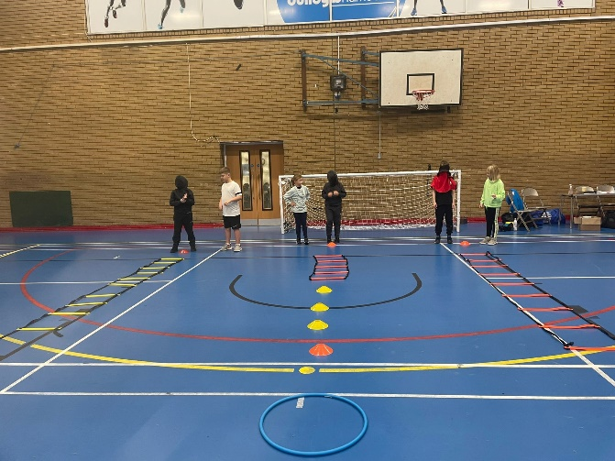
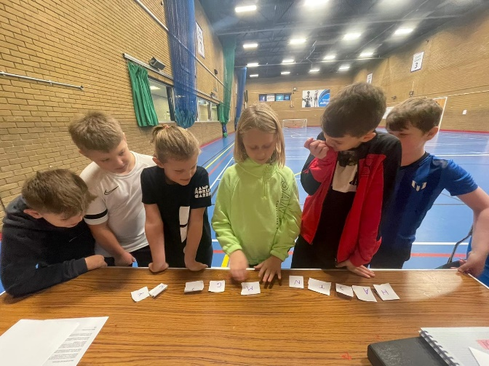

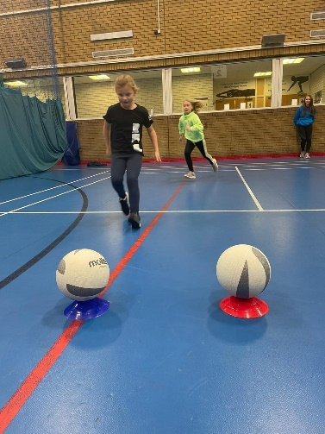

Recommendations for next year if it were to take place
- Earlier promotion and agreement of scheme taking place
- Promoted at Summer Sport Scheme so children/parents become more familiar with the scheme
- Could spaces instead be held for Netball/Football Camps that we run during half term periods as opposed to running a Sport Scheme?

Community clubs to potentially deliver sessions which in turn could result in upturn of membership

Agenda Item 9
Report to Town Council 15th November 2021
Planning Matters

The following planning applications have been received:
21/1019/ FULL 17 St Helen’s Court, Caerphilly CF83 1DL
Erect single storey side extension and porch and carry out alterations to driveway.

Agenda Item 10.1
Report to Town Council 15th November 2021
List of Payments

Cheque No | Payee | In Respect of | Amount £
304135 | Lexon GB Ltd | Newsletter printing | 413.00
304136 | JustWin Marketing | Newsletter distribution | 266.00
Internet | EE Limited | Mobile phone | 21.20
Internet | Digital Systems UK | Printing | 31.00
Direct Debit | Sage Global Services Ltd | Payroll Software | 8.40
304137 | Sense Cymru | Donation | 2,500
304139 | Autistic Minds | Donation | 2,500
Internet | Lite | Christmas Lights | 7,204.80
Internet | HMRC | Income Tax & NI | 562.21
Internet | Admin Assistant | Salary October | 383.31
Internet | Town Clerk | Salary October | 740.59
Direct Debit | NEST | Pension October | 27.95
Internet | T & CCLC | Subscription | 100.00

It is recommended that Members note and approve the payments

Agenda Item 10.2
Report to Town Council 15th November 2021
Bank Account Balances

Bank Account Balances as at 1st November 2021

£

Community Direct Plus Account 125,029.76
Business Select Account 10,639.83
Business Select Account 22,972.09
(Restricted Reserves)

Members to note the information

