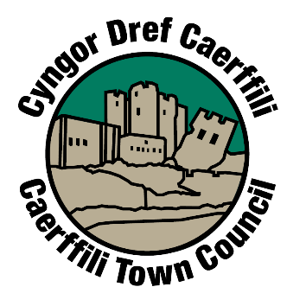

Newsletter Cylchlythyr

Caerphilly In Bloom! Caerffili yn ei Blodau!

Rhif/Number 4 2021
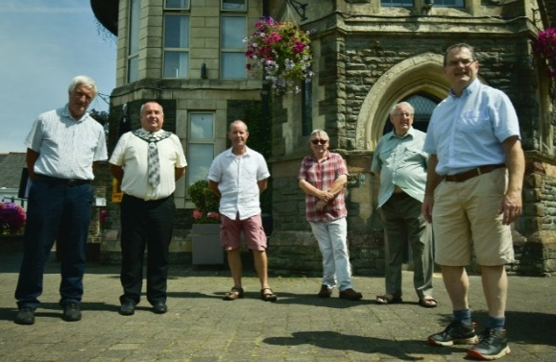
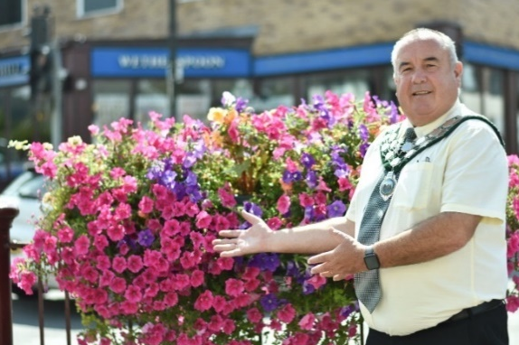
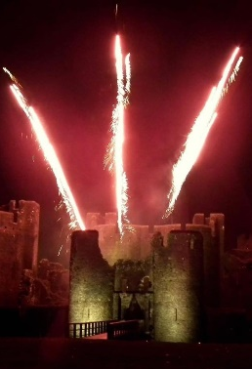

il
At the time of writing, in July, with restrictions easing (but infection rates rising rapidly), we were hopeful that we would be able to press ahead with our Winter events, namely the Annual Fireworks Display, Christmas Lights Switch On, and the Christmas Lantern Parade. However, it was clear at that time, with the need to make financial commitments to the Fireworks in particular, that we could not guarantee that the event could go ahead and that money would be lost in the event of a late cancellation. We were also very disappointed to learn that it would be impossible to comply with even the lowest Covid restrictions, especially with Track and Trace procedures and Social Distancing. Residents will remember that we had to make a similar decision last year when infections were actually falling. It is now clear what happened then to Covid.
Wrth ysgrifennu, yng Ngorffennaf, ac i’r cyfyngiadau liniaru (ond â heintiadau’n codi’r gyflym) rydym yn obeithiol o fwrw ymlaen gyda digwyddiadau’r Gaeaf, fel y Tân Gwyllt Blynyddol, troi’r Goleuadau Nadolig ymlaen a Gorymdaith Llusernau’r Nadolig. Beth bynnag, roedd hi’n amlwg ar y pryd, bod angen ymroi yn ariannol i’r Tân Gwyllt yn arbennig, er na allwn ni warantu y byddai’n mynd yn ei flaen ac y byddai colled ariannol petai’n rhaid gohirio’n hwyr. Rydym hefyd yn siomedig o wybod y byddai’n amhosib bodloni’r cyfyngiadau isaf Covid yn enwedig Tracio ac Olrhain ac Ymbellhau’n Gymdeithasol. Byddwch yn cofio y bu’n rhaid cymryd penderfyniad tebyg y llynedd pan roedd yr heintio mewn gwirionedd yn gostwng. Mae’n glir nawr yr hyn a ddigwyddodd bryd hynny i Covid.

It was encouraging to see the work done by volunteers to clear up weeds and litter in the weeks before the visit, and also the increased interest from businesses in the town such as the Aviary, Gastro Mania, and the Hive as well as Wetherspoons, Quality Carpets and Linc. New contributions were welcomed from Church View Nursing Home and Ty Siriol adding to regular contributors Castle View Residents, Morgan Jones allotments and St Martins Church.
The annual event is funded by the Town Council and co-ordinated by Councillor James Fussell.
.
Roed gweld y gwaith a wnaed gan wirfoddolwyr i glirio’r chwyn a’r sbwriel yn ystod yr wythnosau cyn yr ymweliad yn codi calon, a hefyd mwy o ddiddordeb gan fusnesau’r dref megis, Aviary, Gastro Mania, a’r Hive yn ogystal â Weatherspoon, Quality Carpet a Linc. Croesawir cyfraniadau newydd gan Gartref Nyrsio Church View a Tŷ Siriol yn ychwanegol i’r cyfranwyr rheolaidd, Trigolion Castle Veiw, rhandiroedd Morgan Jones ac Eglwys Sant Martin.
Cyngor y Dref sy’n ariannu’r digwyddiad blynyddol a’r Cynghorydd James Fussell sy’n cydlynu.

Digwyddiadau’r Dref Town Events Cancelled
Caerphilly Town Council Information Gwybodaeth Cyngor Tref Caerffili
More information, including council finance, is available on the council`s website.
Mae mwy o wybodaeth, gan gynnwys cyllid y cyngor, ar gael ar wefan y cyngor.
https://www.caerphillytowncouncil.co.uk/ or phone/neu ffoniwch 02920 888777
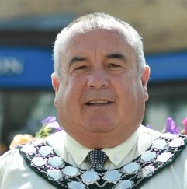

At the Town Council AGM in July, Councillor Mike Prew was re-elected Town Mayor for 2020/21. His chosen charities this year are The Autism Directory and Sense Cymru

Councillor Huw Jackson was re-elected Mike`s Deputy.
Ail-etholwyd y Cynghorydd Mike Prew yn Faer y Dref ar gyfer 2020/21 yn ystod Cyfarfod Blynyddol Cyngor y Dref. Ei elusennau dethol eleni yw’r The Autism Directory a Sense Cymru

Ail-etholwyd Huw Jackson yn ddirprwy i Mike.

Ei ddirprwy fydd y Cynghorydd Huw Jackson.

Mike`s Year as Mayor / Blwyddyn Mike yn Faer
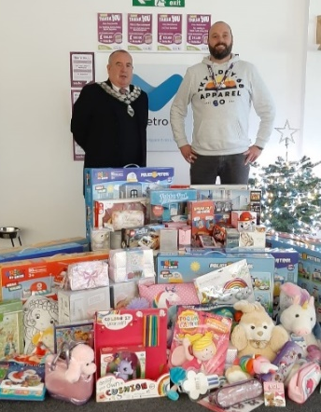
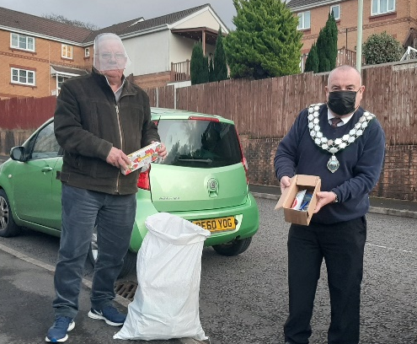
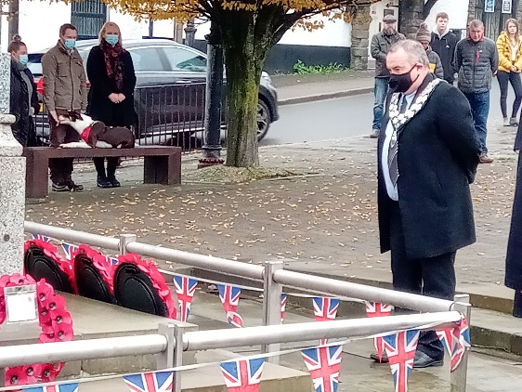
Charities and Voluntary Groups
During Covid, the Town Council has made a number of other donations. We gave £1500 to Llamau and Caerphilly Foodbank in the early part of the lockdown and £1000 to the Breast Unit in Ystrad Fawr. In addition, a number of grants requested by voluntary groups were approved.
Elusennau a Grwpiau Gwirfoddol
Yn ystod Covid, gwnaeth Cyngor y Dref nifer o gyfraniadau eraill. Rhoddwyd £1500 i Llamau a Banc Bwyd Caerffili yn ystod cyfnod cynnar y cloi lawr a £1000 i Uned Brestiau Ystrad Fawr. Yn ychwanegol, cytunwyd ar nifer o grantiau a wnaed ar gais grwpiau gwirfoddol.

Molly meets the Mayor
One of the more pleasurable events was meeting Molly Latham of Cwrt Rawlin Primary school for an interview. Molly produced a PowerPoint which she has shared with us on our website .

Molly’n Cyfarfod y Maer
Un o’r profiadau mwyaf pleserus oedd cyfarfod â Molly Latham o Ysgol Gynradd Cwrt Rawlin am gyfweliad. Cynhyrchodd Molly BwyntPwer y mae wedi rhannu gyda ni ar ein gwefan.

Vetro Recruitment
Recriwtio Vetro

With The Lions December 2020
Gyda’r LLewod yn Rhagfyr 2020

Remembrance Day Diwrnod y Cofio Remembrance Day

Owing to the Covid Crisis, many events were cancelled. This included the presentation of cheques to the Mayor`s Charities, the Caerphilly Lions and Mind Cymru. As the main event for raising money for the charities, the Fireworks Display, were cancelled, the Town Council agreed to donate £2,500 to each charity.
Oherwydd Argyfwng Covid, diddymwyd nifer o ddigwyddiadau. Mae hyn yn cynnwys cyflwyno sieciau i elusennau’r Maer, Llewod Caerffili a Mind Cymru. Am fod y prif ddigwyddiad ar gyfer codi arian i elusennau, yr Arddangosfa Tân Gwyllt, wedi’i ddiddymu, cytunodd Cyngor y Dref gyfrannu £2,500 i bob elusen.

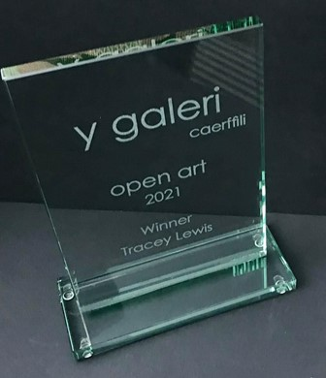
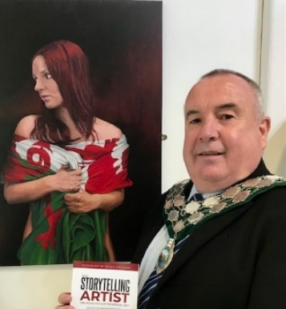
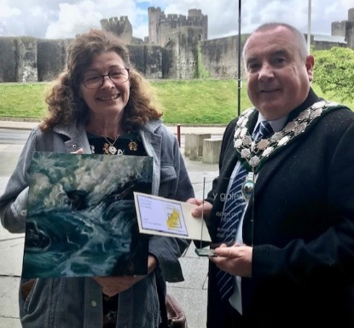
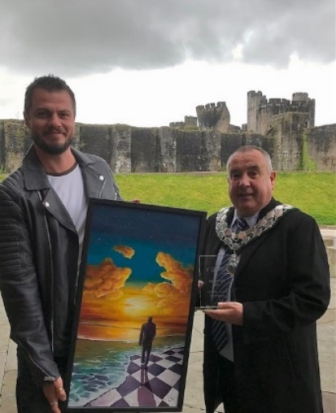
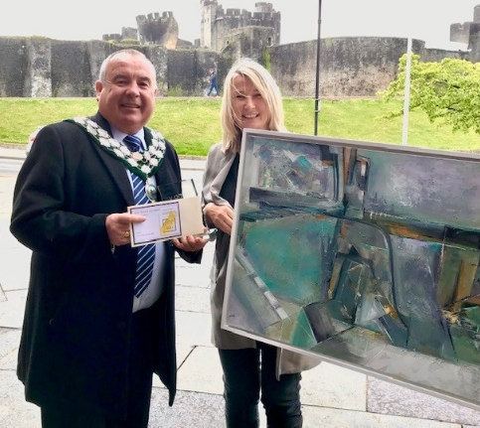
The Visitors Choice award selected by voters on-line and in the gallery went to Ian Mackenzie for “Land of Passion”
Aeth Dewis yr Ymwelwyr a ddewiswyd gan bleidleiswyr ar-lein ac yn y galeri i Ian Mackenzie am “Gwlad Llawn Angerdd”.

The Town Council would like to thank Jan and Gareth Pennell for all their hard work in organising the Open Art Competition, the judges for their time and effort freely given, and a huge thank you to all participating artists who make this event possible. Without their support and their participation the Open Art wouldn’t happen.

Hoffai Cyngor y Dref ddiolch i Jan a Gareth Pennell am eu holl waith caled wrth drefnu’r Gystadleuaeth, y beirniaid am eu hamser a’u hymdrech a roddwyd yn rhad ac am ddim, a diolch mawr i bob un ohonoch a gymerodd rhan a wnaeth y digwyddiad yn bosib. Heb eu cefnogaeth a’u bod yn cymryd rhan,ni fyddai’r Arlunio Agored yn digwydd.

Twelve Artists were Highly Commended :
Derbyniodd Deuddeg Artist Glod Uchel:

Susan Barber “April Showers” Meg Bateman “Our Wonderful NHS” Maureen Clarkson “Strawberries and Cream” Patricia May Clark “Deserted” Elizabeth Elsworth “ Poppy Field” Sid Head “The Hayes, Cardiff” Janet Howe “ Mad Hatter” Lorraine Howells “ Blue Water, Rest Bay” Ian Mackenzie “Land of passion Gwlad . Llawn Gerdd” Joanna Richards “Essence of Bone 3” Jackie Shackson “Church Rock” Haf Weighton “First Glimpse of the Sea”
The winner of the Lannion Award selected by Caerphilly Town Mayor Mike Prew went to Lion Pascal for his painting “Gambit”
Enillydd Dyfarniad Lannion, a ddewiswyd gan Faer Tref Caerffili, Mike Prew, oedd Lion Pascal am ei baentiad “Gambit”.

The Caerphilly Open Art Competition sponsored by Caerphilly Town Council, attracted submissions from artists across Wales and beyond. 106 artworks were selected to form the annual exhibition. A panel of three judges, David Chamberlain, Senior Arts Development Manager for Caerphilly Borough Council, artist Louise Collis, and ceramicist and winner of last years competition Kim Colebrook selected the winning artwork and runner up.
Denodd Cystadleuaeth Arlunio Agored Caerffili, a noddwyd gan Gyngor Tref Caerffili, gynigion gan artistiaid o Gymru ben baladr a thu hwnt. Dewiswyd 106 darn o waith o’r arddangosfa flynyddol. Dewisodd panel o dri beirniad, David Chamberlain, Uwch Swyddog Datblygol Arlunio Cyngor Bwrdeistref Caerffili, artist Louise Collis, ac enillydd ceramig cystadleuaeth y llynedd, Kim Colebrook y gwaith buddugol a’r un ddaeth yn ail.

Gigi Jones was awarded runner up and £250 for her painting “Time and Tide”
Cyflwynwyd yr ail wobr a £250 i Gigi Jones am ei phaentiad “Amser a’r Llanw”

First Prize and £750 was awarded to Tracey Lewis for her painting “within the Harbour
Cyflwynwyd y wobr gyntaf o £750 i Tracey Lewis am ei phaentiad “o fewn Waliau’r Harbwr”

Walls”
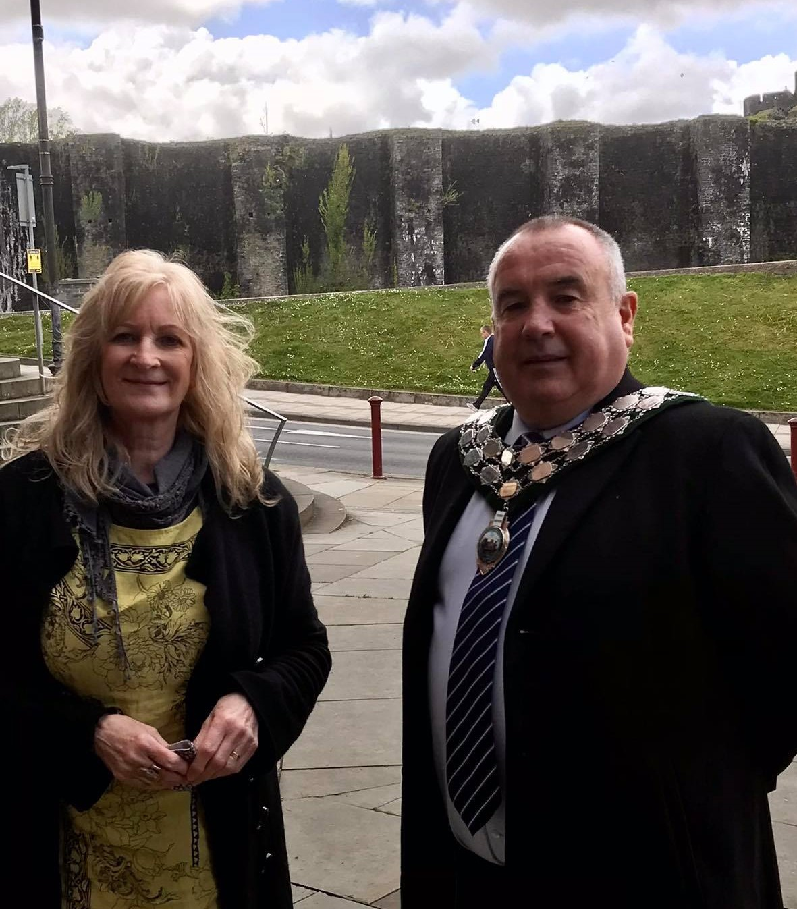



Town Councillors Cynghorwyr y Dref






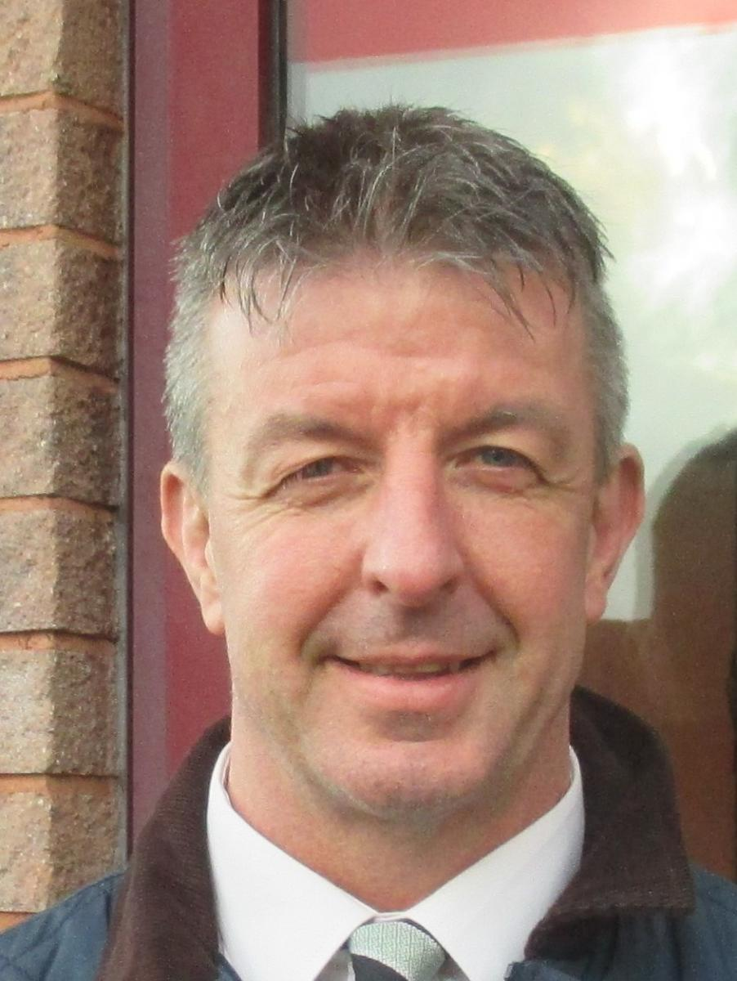

Ward - Parcyfelin Cllr Shelly Hodder (Welsh Labour/ Llafur Cymru)
26, Heol Gwaun Rhos, CF83 3ER
07761 633637 shelleyhodder@msn.com

Ward - Cwrt Rawlin Cllr James Fussell (Plaid Cymru), 10 Clos Enfys, Castle View, CF83 1SB
07725 191365 jamesfussell@caerphilly.gov.uk

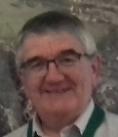
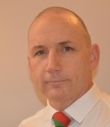



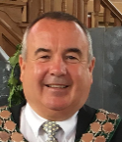
Yn gynharach eleni penderfynodd Cyngor y Dref ddal yr archebiant o £15.50 ar gyfer eiddo Band D. Telir am bron i bob peth a wna’r Cyngor drwy’r archebiant hwn ar Dreth Cyngor trigolion. Yn gyffredinol mae’r archebiant cyfwerth a tua £1.29 y mis i bob cartref Band D.
Mae’r archebiant yn talu am ddigwyddiadau blynyddol fel yr Ŵyl Flodau a’r Tân Gwyllt. Codir arian ychwanegol drwy Lefel Cymunedol Isadeiledd a geir drwy ddatblygiadau adeiladu yn y dref.
Yn y cyfamser, rydym yn parhau i gefnogi grwpiau gwirfoddol lleol drwy grantiau cymorth. Am fanylion llawn a ffurflen gais am grant, ewch at ein gwefan.

N.B. Members may be absent for a variety of reasons such as illness, technical issues other engagements or family reasons.
Gall cynghorwyr fod yn absennol am amryw resymau megis salwch, problemau technegol ymrwymiadau eraill neu resymau teuluol.

Cyng./Coun. | %
Phil Bevan | 100
Colin Elsbury | 91
Steve Kent | 91
Jenny Hibbert | 100
Jeff Grenfell | 100
Mike Prew | 91
Shelley Hodder | 64
Huw Jackson | 91
Simon Morgan | 73
James Fussell | 100
James Pritchard | 100
Roger Bidgood | 45

Earlier this year the Town Council decided hold its precept £15.50 for a Band D property. Almost all that the Council does is paid for by this precept on residents Council Tax. In general the precept equates to about £1.29 per month per Band D household.
The precept pays for annual events such as the Flower Festival and Fireworks. Additional money is raised through the Community Infrastructure Level from building developments in the town.
In the meantime we continue to support local voluntary groups with grant aid. For full details and a grant application form, please see our website
Finance 2020/21 Cyllid
Attendance 2020/2021 Presenoldeb
Council Meetings are held in the Twyn Community Centre each month at 6.30pm on the third Monday, except August.
Owing to to Covid restrictions the council meets on line. Details from our website.
Cynhelir Cyfarfodydd y Cyngor yng Nghanolfan Gymunedol y Twyn bob mis am 6.30yh ar y trydydd dydd Llun, heblaw am fis Awst.

Oherwydd cyfyngiadau Cofid mae’r cyngor yn cyfarfod ar-lein. Manylion ar ein gwefan.
Ward - Bryncenydd Cllr James Pritchard (Welsh Labour/ Llafur Cymru)
36, Celyn Avenue, CF83 3FL
07854 348033 jamespritchard@caerphilly.gov.uk

Ward - Castle Cllr Jenny Hibbert (Plaid Cymru)
255, Nantgarw Road, CF83 1BU
02920 869395 / 07761 242992
jennyhibbert255@googlemail.com

Ward - Castle Cllr Stephen Kent (Plaid Cymru)
29, St David's Way,CF83 1EY
02920 886362 / 07974 007414 stephenkent@caerphilly.gov.uk

Ward -Twyn Cllr Jeffrey A. Grenfell (Plaid Cymru)
14, Bronrhiw Avenue, CF83 1HF
07968 068933 jeffgrenfell.ctc30@outlook.com

Ward - Twyn Cllr Huw Jackson (Plaid Cymru)
The Firs, Watford Road, CF83 1NE
02920 864979
huwjackson.ctc35@outlook.com

Ward - Watford Cllr Simon Morgan (Plaid Cymru)
19, Maes Watford,CF83 1LP
07973 302199
simon.morgan65@outlook.com

Ward - Parcyfelin Cllr Roger Bidgood (Plaid Cymru)
20, Clos Dwyerw, CF83 1TE
02920 868436 rogerbidgood1@outlook.com

Ward - Parcyfelin Cllr Phil Bevan (Plaid Cymru)
75 Pontygwindy Road, CF83 3HG 02920 866185 / 07528 339577
philbevan@caerphilly.gov.uk

Ward - Cwrt Rawlin Cllr Colin Elsbury (Plaid Cymru)
13 Bryn Gwyn, CF83 1ES
07891 925578 colinelsbury@caerphilly.gov.uk

Ward -Tonyfelin Community Cllr Mike Prew (Plaid Cymru)
9,Dol-y-Felin Street, CF83 3AP
07791 430016 mikeprewgos@outlook.com

