C A E R P H I L L Y T O W N C O U N C I L
C Y N G O R T R E F C A E R F F I L I

TOWN CLERK: TOWN MAYOR: CLERC Y DREF: MAIR Y DREF:
P. G. Davy Cllr Mike Prew

12th July 2021

An Ordinary Meeting of the Caerphilly Town Council will be held on Monday 19th July
2021 at 6.30 pm by Remote Access

Any Member requiring further information on any item should contact me before the Meeting.

Phil Davy
Town Clerk

A G E N D A

1. To note Members’ attendance and to receive any apologies for absence.

2. Declarations of Interest in any item.

3. To receive and if thought fit to confirm the Minutes of the Ordinary Council Meeting
held on Monday 21st June 2021. .

4. Matters arising from the Minutes if not covered by the Agenda.

5. COMMUNITY SAFETY MATTERS

6. TOWN MAYOR’S DIARY

7. ENVIRONMENTAL MATTERS

8. TOWN CLERK’S REPORTS

8.1 Fireworks Display and Christmas Events 2021.
8.2 Q1 Budget Monitoring (2021/22 Financial Year).
8.3 The Community Council Clerk Qualifications Regulations.
8.4 Replacement Notice Board
8.5 Hybrid Town Council Meetings – Technical Requirements

Address: The "Twyn Community Centre The Twyn Caerphilly CF83 IJL
Telephone: Caerphilly 07950 935822 E-mail: caerphillytowncouncil@outlook.com
Office hours: Monday, Tuesday and Wednesday mornings 9.30 a.m. to 12.30 p.m.

9. PLANNING MATTERS

10. PAYMENT AND FINANCIAL MATTERS

10.1 List of payments.
10.2 Bank Account Balances.
10.3 Application for Financial Assistance

11. CORRESPONDENCE

12. MEMBERS REQUESTS FOR FUTURE REPORTS

This Meeting will be held in accordance with Section 47 of the Local Government and Elections (Wales) Act 2021 by remote access. Any member of the public or media wishing to attend this meeting should contact the Town Clerk at:

caerphillytowncouncil@outlook.com

All documentation about and relating to this and any other Town Council Meetings undertaken either in person or by remote access will be made available on the Town Council Website.

www.caerphillytowncouncil.co.uk

C A E R P H I L L Y T O W N C O U N C I L
C Y N G O R T R E F C A E R F F I L I

TOWN CLERK: TOWN MAYOR: CLERC Y DREF: MAIR Y DREF:
P. G. Davy Cllr Mike Prew

MINUTES OF THE ORDINARY MEETING OF THE CAERPHILLY TOWN COUNCIL
HELD BY REMOTE ACCESS ON MONDAY 21ST JUNE 2021

Present:
Councillors P J Bevan, R Bidgood, C Elsbury, J Fussell, J Grenfell, S Hodder, H Jackson,
S Kent, S Morgan, M Prew, J Pritchard

Apologies:
Councillor J Hibbert
In Attendance:
P G Davy, Town Clerk
25 MINUTES OF THE ORDINARY TOWN COUNCIL MEETING HELD ON 17TH MAY 2021
Minutes of the Ordinary Town Council Meeting held on 17th May 2021 were received and confirmed. Minutes to be signed by the Town Mayor when practical.
26 MATTERS ARISING
Minute 16 – grant application from Gwent Police to support initiative at Morgan Jones Park had not been received.
27 COMMUNITY SAFETY MATTERS
Attention was drawn to an item of play equipment at Morgan Jones Park that required better protection for the public due to the nature of its operation. Members were in contact with CCBC on the matter.
Members noted recurring incidents in Morgan Jones Park and advice to residents to call 101.
28 TOWN MAYOR’S DIARY
The Mayor had met with his two charities He advised that the Autism Directory had been rebranded as Autistic Minds. The charity had a particular focus on assisting adults with autism into employment.
The Mayor thanked everyone involved in renewing the planters around the town.

Address: The "Twyn Community Centre The Twyn Caerphilly CF83 IJL
Telephone: Caerphilly 02920 888777
E-mail: caerphillytowncouncil@outlook.com
Office hours: Monday, Tuesday and Wednesday mornings 9.30 a.m. to 12.30 p.m.

29 ENVIRONMENTAL MATTERS
No new issues raised.
30 TOWN CLERK’S REPORTS

1 Review of Working Arrangements for Town Council

It had been agreed to undertake a review of the working arrangements that would be implemented once the coronavirus restrictions had been lifted and taking account of the experience gained over the last 15 months since the office was closed in March 2020.
The working arrangements during the pandemic have had a positive environmental benefit and a reduction in carbon footprint. There has been minimal travelling to the office and a reduction in use of printing / paper as all members have received electronic copies of agendas, minutes and reports. Although the office is rented there have been savings in heating and lighting, and other sundry office costs. Attendance at the remote access meetings has been higher than the pre pandemic physical meetings.

It was resolved:

1 Hybrid Town Council meetings are adopted from September 2021 (dependent on
any ongoing Covid 19 restrictions) enabling both in person and remote access to comply with the LGE Act 2021, and subject to making appropriate IT arrangements.

2 To pursue relocating the Town Council Meetings to the Main Hall subject to availability.

3 Fixed office hours are discontinued and replaced by an appointment system operating over five days a week.

4 The office landline is discontinued and replaced with an office mobile phone.

5 The office is made available for use by both staff and Members using an electronic
diary / booking system, and subject to implementing the office door control as previously approved.

6 A flexible approach to homeworking / office working is introduced allied to the
wider use of the office in 5.

31 PLANNING MATTERS

The following planning applications were considered, and comments made as follows:

21/0387/COU – no objections
21/0397/FULL – no objections
21/0454/FULL – no objections
21/0462/FULL – no objections
21/0470/ADV – no objections
21/0487/FULL – no objections
21/0469/FULL – no objections

21/0477/RM – Members reiterated their opposition to the loss of a greenfield site, and the impact on local infrastructure due to the scale of the development. There are aspects of the reserved matters application that are unsatisfactory including the inadequate screening and

the layout of footpaths. The footpath from the site to Larch Grove is unsafe as it leads onto a blind bend.

21/0509/COU – Members raised objections on grounds of unsuitability of property due to its location and limited size. The proposed use would result in noise and disturbance, and highway safety concerns resulting in an adverse impact on residential amenity.

21/0445/FULL – no objections

21/0452/FULL – Members raised objections due to the overdevelopment of the site, the increase in traffic generation, and due to the height of the development the overbearing impact on the visual amenity of the town centre.

21/0485/FULL – no objections
21/0520/FULL – no objections
21/0571/FULL – no objections
21/0578/FULL – no objections
21/0579/ADV – no objections

Councillor J Fussell declared an interest and took no part in the discussion or decision making on any of the applications.

32 PAYMENTS AND FINANCIAL MATTERS

1 List of payments were noted and approved. It was noted the payee in respect of the insurance renewal is Came and Company.

2 Bank account balances were noted.

3 Application for Financial Assistance

Aber Valley Wolves Rugby League Club

A grant of £400 was approved. Expenditure authorised under Local Government
Act 1972, section 137. Councillor J Grenfell declared an interest and took no part
in the discussion or decision making on the grant application.

33 CORRESPONDENCE

It was resolved that under the terms of Section 1(2) of the Public Bodies (Admission to Meetings) Act 1960 that because publicity would be prejudicial to the public interest by reason of the confidential nature of the business to be transacted the public and press be excluded from the meeting during the consideration of this item.

It was agreed to support the proposal for a community recognition St David Award.

34 MEMBER REQUESTS FOR FUTURE REPORTS

A request was made for a report on a replacement notice board given the poor condition of the existing notice board.

The meeting closed at 7.40pm

Agenda Item 8.1
Report to Town Council 19th July 2021
Fireworks Display and Christmas Events 2021

At the Town Council meeting on 19th April 2021, it was agreed that a decision would need to be made at the July Town Council whether to proceed with the planning for the fireworks display and Christmas events for 2021 having regard to the Welsh Government guidance at July relating to coronavirus restrictions.
To date the only action that has been taken concerning the events is to make a provisional booking with Cadw for the fireworks display at Caerphilly Castle on 6th November 2021. The application has been acknowledged and a risk assessment, method statement, and evidence of public liability insurance has been submitted to Cadw. The risk assessment for the event assumes that all coronavirus restrictions will have been removed and that no control measures will be necessary.
At the time of writing the report Wales remains at Alert Level 2 but with anticipated progression to Alert Level 1. Welsh Government has confirmed that large outdoor gatherings and events, such as concerts, football matches and sporting activities can go ahead for up to 4000 people standing and 10000 people seated. All organisers planning events and activities must undertake a full risk assessment and put in place measures to prevent the spread of coronavirus, including social distancing.
The fireworks display, Christmas lights switch on, and Christmas Lantern Parade will fall under the category of regulated events. The organiser of the activity must meet requirements in the regulations to undertake a risk assessment and take all reasonable measures to minimise risk of exposure to coronavirus. The relevant guidance is issued under the Health Protection (Coronavirus Restrictions) (No 5) (Wales) Regulations 2020. The guidance is drafted in terms of obligations on people responsible for premises open to the public. This creates a difficulty as the Town Council events take place in open access areas where it would be impossible to implement control measures such as social distancing. In the case of organised activities, the duty in law to take reasonable measures applies to both the person responsible for the premises where the activity is taking place and the person responsible for the activity. The Town Council would not therefore be absolved from taking appropriate measures just because the activities are not within controlled premises. It may therefore be concluded that while there is a risk of transmission of coronavirus and due to the nature of the event it is not possible to reduce the risk of exposure to the virus because social distancing cannot be controlled then the only means of minimising the risk is for the event not to take place.
Rates of infection within Wales are currently low but it is impossible to predict what the position may be in November. When thinking about what is reasonable it is important to consider the alert level in force. As the alert level changes this has an effect on what is reasonable to do, but this will also be affected by variants of the virus emerging that spread more easily. This is the current concern with the Delta (Indian) variant which has led to a delay in the lifting of restrictions across all the home nations. At a press conference on 5th July the Prime Minister indicated the intention that from 19th July all legal coronavirus restrictions in England should be lifted, including social distancing, the compulsory wearing of face masks, and the limits on numbers attending events and live performances. It remains to be seen if Wales will follow with the same action. It is worth noting that the First

Minister, Mark Drakeford is on record as saying social distancing may be in place for the remainder of the year. The Chief Medical Officer for Wales is on record with the following statement:
“The need for the Welsh public to continue personal protective behaviours during the summer and into the autumn should be consistently communicated; isolation and testing for anyone who develops symptoms, regular hand hygiene, the use of face coverings in crowded indoor settings and social distancing all have an important place in mitigating the risk of transmission.”
A decision about the events has to be taken now due to the planning necessary and the contracting with suppliers cannot be deferred. If the Town Council proceeds with arranging the events assuming that restrictions will be lifted but subsequently this proves not to be the case or new restrictions have to be imposed during the autumn, there is the likelihood of incurring abortive costs if the events have to be cancelled at short notice.
As a public body the most appropriate course of action is to take a decision based on the current guidance, accepting that the guidance may change by November. As the events are not on controlled premises it will be impossible to regulate numbers attending which for the fireworks could exceed 4000 standing. It will also be difficult to enforce social distancing, but this should be weighed against the fact that the events are of short duration and outside. Nor will it be practical to take contact details of those attending if track and trace becomes necessary. Given the inability to implement reasonable measures due to the nature of the open events the precautionary approach to minimising the risk of exposure to the virus would be for the events not to take place in 2021.
The next Welsh Government review of restrictions is on 15th July 2021. Clearly if Welsh Government indicate the intention to lift all restrictions, to mirror England, and confirm the date this will happen this could open the way for the events to proceed.
The agenda has to be published before the 15th July 2021. Any changes that may affect the considerations outlined in the report will be updated verbally at the Town Council meeting.
Members will have to decide on the most appropriate course of action taking account of the Welsh Government review.
Phil Davy
Town Clerk

Agenda Item 8.2
Report to Town Council 19th July 2021
Q1 Budget Monitoring (2021/22 Financial Year)

Comparison of actual expenditure to annual estimate for the period to 1st April 2021 to 30th June 2021.

Main Budget Heads | Q1 Actual £ | Annual Estimate £
Mayor’s Allowance | 225.00 | 900.00
Members Allowances | 600.00 | 1800.00
Staff Costs | 5148.48 | 20887.00
Travelling Expenses | 0 | 500.00
Audit Fee | 200.00 | 400.00
Insurance | 1766.53 | 1800.00
Office Costs | 1173.77 | 10000.00
Sponsored Events | 1050.00 | 16350.00
Concessionary Hires | 0 | 0
Fireworks Display | 0 | 16000.00
Fireworks Charity Donation | 0 | 4000.00
Floral Decorations | 0 | 16000.00
Christmas Lights | 0 | 9000.00
Lantern Parade | 0 | 9000.00
Financial Assistance | 400.00 | 6000.00
Summer Sports Scheme | 0 | 5000.00
Newsletter | 0 | 900.00
Elections | 0 | 0
Miscellaneous | 580.00 | 200.00
VAT | 194.19 | Inc in estimates
CIL Projects
TOTAL | 11,337.97 | 118,737.00

£

Budget for 2021/22 118,737.00

Actual expenditure to 30.06.21 11,337.97
(9.5% of budget)

Members are invited to note the report.

Agenda Item 8.3
Report to Town Council 19th July 2021
The Community Council Clerk Qualifications Regulations

Welsh Government is consulting on regulations which specify the qualifications the clerk to a town or community council must hold to enable the council to exercise the general power of competence.
Section 24 of the Local Government and Elections (Wales) Act 2021 (LGE Act 2021) gives “qualifying local authorities” a general power of competence. The general power gives these authorities the power to do anything that an individual can do, provided they act rationally and within the law. An eligible community council is a council which meets the conditions set out in section 30 of the LGE Act 2021, or in regulations made by Welsh Ministers under section 35 of the LGE Act 2021 and passes a resolution that it meets the conditions.
The conditions a community council must satisfy in order to resolve itself an eligible council are:
- At least two thirds of the total number of members of the council have been declared to be elected, whether at an ordinary election or at a by-election

- The clerk of the council holds such qualification or description of qualification as may be specified by the Welsh Ministers by regulations

- The council has received unqualified auditor’s opinions from the Auditor General for Wales for two consecutive financial years. The latest unqualified auditor’s opinion must have been received during the 12 months preceding the day on which the council’s resolution is passed
The consultation specifies the proposed qualifications under the second condition. Welsh Ministers have considered the case for broadly aligned professional qualifications, or “time-served” in the role of clerk but have rejected these in favour of sector specific qualifications.
The proposed list of qualifications and the relevant awarding bodies are as follows:
- The Certificate in Local Council Administration (CiLCA), accredited by Ascentis

- The Certificate of Higher Education in Community Governance, validated by De Montfort University

- The Certificate of Higher Education in Community Engagement and Governance, awarded by University of Gloucestershire

- The Certificate of Higher Education in Local Policy, awarded by University of Gloucestershire
Obtaining any of the qualifications listed above would be considered to demonstrate a sound understanding of the operation of local government and principles of good governance. The clerk to the council must hold one or more of the above qualifications at the time, or before the council passes a resolution that it meets the criteria for an eligible community council. It would be insufficient to declare that the clerk is currently undertaking one of the qualifications, or is intending to undertake one at a future date.

The Town Council’s Clerk does not currently hold any of the qualifications listed. Assuming Welsh Government approves the Regulations without any amendments this would only become an issue if at some future point the Town Council decided that it would like to have the general power of competence. The lack of the general power does not affect any of the activities currently undertaken. Reliance can continue to be placed on specific legal powers which already cover a wide range of discretionary activities. The benefit of the general power is that it avoids the need to check whether a specific provision has been enacted.
The report is for information.
Phil Davy
Town Clerk

Agenda Item 8.4
Report to Town Council 19th July 2021
Replacement Notice Board

A report was requested at the last meeting on replacing the Town Council notice board.
The current wall mounted external notice board is in poor condition due to weather and general wear and tear. In addition, it is not in a very prominent location being tucked around the corner away from the main entrances to the Twyn building.
Two companies that specialise in the supply of notice boards have been asked to provide quotations for two options.
Option one is a replacement wall mounted external notice board with header that will accommodate 12 A4. This will be in the same location as the existing notice board.
Option two is for a post mounted freestanding dual door external notice board with header that will accommodate 18 A4. It is envisaged this would be located in a suitable position on the paved area in front of the Twyn building.
Only one company has responded and the quotations are:
Option 1 £442-80 +vat+delivery
Option 2 £798-30+vat+delivery
The prices quoted are for supply only. There would therefore be additional costs associated with installation. For budget purposes say total cost option 1 £1000, and option 2 £2000.
There are additional considerations with option 2 as consent will be required from the landowner (CCBC) and a planning application will be required which will incur a fee.
Option 1 is more straightforward as a replacement of the existing and can be considered as maintenance.
No specific budget provision has been made for replacing the notice board but it is anticipated that savings will arise during the year that will enable a virement to the office administration budgets to meet the cost of either option 1 or 2.
Members are invited to determine how they wish to proceed.
Phil Davy
Town Clerk

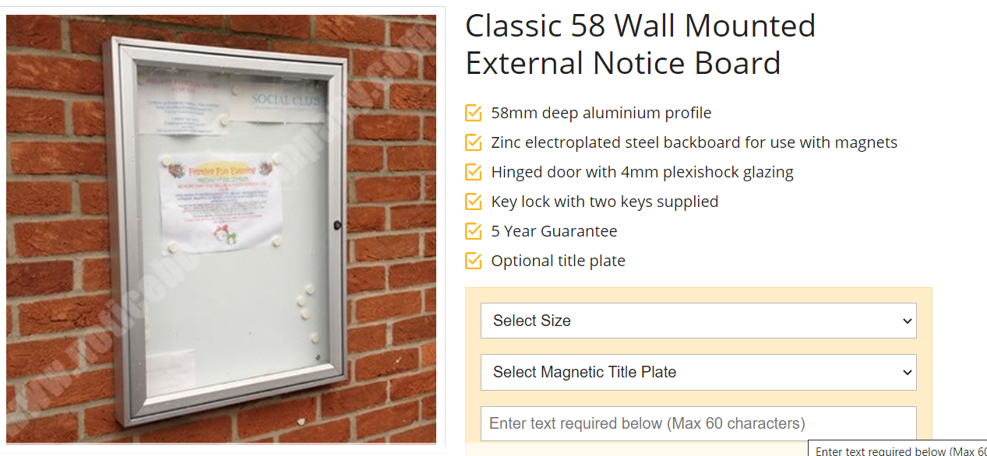

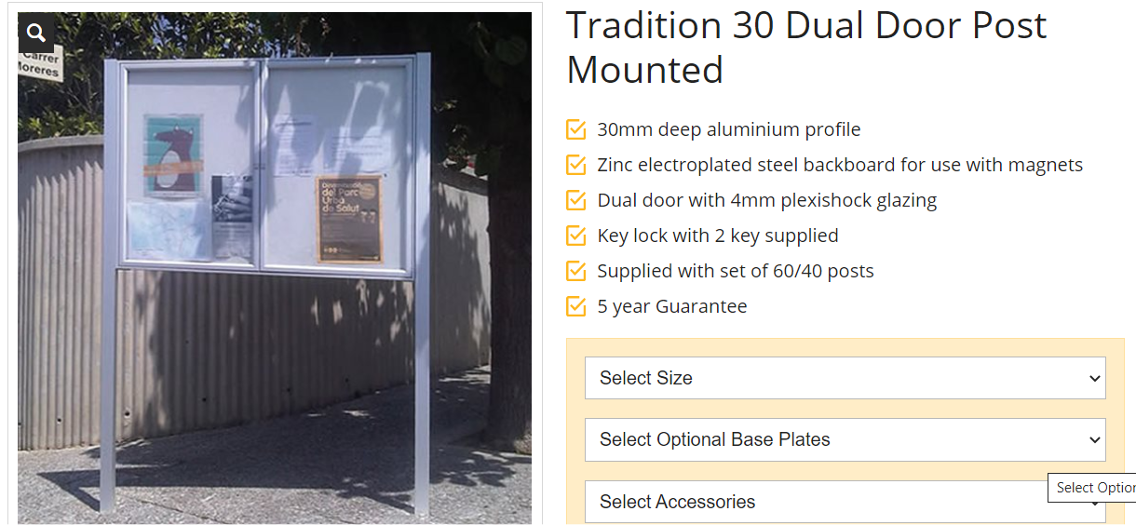

Agenda Item 8.5
Report to Town Council 19th July 2021
Hybrid Town Council Meetings – Technical Requirements

At the Town Council meeting on 21st June it was resolved to adopt hybrid Town Council meetings from September 2021 that would comply with the Local Government and Elections Act 2021 and enable both in person and remote access participants to both see and hear each other. The was subject to investigating and acquiring additional IT equipment to enable hybrid meetings.
The Main Hall has been booked for the Town Council meetings in September, October and November but equipment should be interchangeable between the Main Hall and the New Meeting Room if meetings revert to the latter in 2022.
Two main elements are already available, the large TV display screens in the Main Hall and in the New Meeting Room, and a laptop. The Town Council purchased a new laptop last year to facilitate home working and the Town Clerk has used this to host Zoom meetings from home. The laptop can be connected to the large display screen using a HDMI cable. Using the wifi in the community centre to connect to the internet this will enable the remote access participants to be linked to the meeting at the Twyn.
The missing elements at the moment relate to linking the in person participants who are present in the community centre. Two companies have been approached to advise on the best solution and to quote for the additional equipment together with initial support, testing and training. Company A has advised the purchase of a camera, speaker, and microphones will enable a full functioning hybrid meeting. The microphones will connect to the camera, which includes the speaker, the camera is then connected to the laptop via a USB cable. Once the equipment is all connected it is enabled via Zoom. Company B has followed similar principles but has quoted on different equipment including a dedicated pc which offers more flexibility for freestanding video conferencing, and doesn’t rely on the Town Clerk’s laptop being present at the Twyn to run a meeting.
Company A ( Gloucestershire )
The quote is built around the Vaddio Conference SHOT bundle. The system consists of a controllable conference camera, a speaker and two wired table microphones. This system can be connected to a laptop via a single USB cable providing camera and audio to the connected participants.
£2,716 -24 +vat
Company B ( Cardiff )
The quote is based on a Poly Studio Soundbar which is an all in one system with a microphone, speaker and camera which can be used with a PC to connect to the internet. The microphone has an acoustic fence and noise block which cuts out unwanted background noise such as paper rustling. The camera is fitted with group tracking and speaker tracking. The proposal is ideally suited to the New Meeting Room. The Main Hall presents some difficulties due to its size and the amount of echo and reverberation. This will be a challenge for any equipment unless significant expenditure is incurred on improving the acoustics.
£2051-85 +vat

Company B has submitted a lower cost quotation that includes a dedicated pc which offers the flexibility for freestanding video conferencing. The quotation is more detailed than Company A. Company B has visited the Twyn community centre and viewed the New Meeting Room and Main Hall. Company B has also offered a 2 year service / maintenance contract to include 1 service visit and 2 emergency call outs per annum at a cost of £892-50 + vat.
This expenditure has not been budgeted but there will be savings on other budget heads during 2021/22 and higher balances were carried forward into the current financial year. A virement can be made to the IT /IT Support budget to cover the cost.
Note this report does not address the adequacy of Members IT. All participants whether Members, police, or general public will be dependent on their own devices and internet connection if they wish to attend the meeting by remote access.
It is recommended that Drake Audio Visual (Company B) is appointed to supply the equipment and technical support for setting up a full functioning hybrid meeting at a cost of £2051-85 + vat.
Members are also requested to decide whether they want to take up the 2 year service / maintenance contract with Drake at a cost of £892-50 + vat.
Phil Davy
Town Clerk

Company A Vaddio Conference SHOT AV Bundle

Company B Poly Studio Soundbar

Agenda Item 9
Report to Town Council 19th July 2021
Planning Matters

The following planning applications have been received:
21/0615/FULL Laagan 46 Mountain Road, Caerphilly CF83 1HL
Erect 2 storey side extension with the addition of front and rear dormers

21/0644/COU Land rear of 109 St Martins Road, Caerphilly CF83 1EH
Change of use of disused railway land into garden use

21/0634/FULL 6 Bronrhiw Avenue, Caerphilly CF83 1HF
Erect hipped roof conservatory to rear of dwelling

21/0196/NCC 1 Cae Uwchllyn, Caerphilly CF83 1TY
Vary condition 2 (approved plans) of planning consent 20/0884/FULL (Erect two storey side extension) to add a French door and balcony to the rear bedroom of the extension to add extra natural light to the room

21/0657/FULL 37 Waun Draw, Caerffili CF83 3SL
Erect front porch

210574/FULL The Rhos, Bedwas Road, Caerphilly
Erect residential development, including demolition / removal of existing structures, for the erection of 31 affordable dwellings and associated works including sustainable drainage, car and bicycle parking and landscape planting.

21/0664/FULL Bryn Glas, 256 Pontygwindy Road, Caerphilly CF83 3HY
Erect gazebo in rear garden

Agenda Item 10.1
Report to Town Council 19th July 2021
List of Payments

Cheque No | Payee | In Respect of | Amount £
Direct Debit | Sage Global Services | Payroll Software | 2.52
304128 | M Prew | Mayor’s Allowance (1) | 225.00
Internet | HMRC | Income Tax & NI | 562.21
Internet | Admin Assistant | Salary June | 383.31
Internet | Town Clerk | Salary June | 740.59
Direct Debit | NEST | Pension June | 27.95
304129 | Aber Valley Wolves RL | Grant | 400.00
Debit Card | Zoom Video Comms Inc | Subscription Renewal | 143.88

It is recommended that Members note and approve the payments.

Agenda Item 10.2
Report to Town Council 19th July 2021
Bank Account Balances

Bank Account Balances as at 1st July 2021

£

Community Direct Plus Account 104,966.00
Business Select Account 10,638.13
Business Select Account (Restricted Reserves) 22,968.46

Members to note the information

Agenda Item 10.3
Report to Town Council 19th July 2021
Application for Financial Assistance

Caerphilly County Borough Taxi Drivers Association (CCBTDA)
An application has been received from CCBTDA for a capital grant to install a coin entry system on the disabled facility at the bus station public convenience. The amount of public funding sought is £2,500 (ex vat)
Members will recall the history. Following the decision of CCBC to close the bus station public convenience the CCBTDA entered a tenancy agreement with CCBC to manage and maintain the public convenience. In order to defray the running costs coin entry systems were installed on the male and female toilets but not the disabled facility. The latter has been the subject of abuse with keys easily available on the internet. This resulted in the CCBTDA deciding to close the disabled facility. However under the terms of the tenancy agreement CCBC has requested that it is reopened.
The Town Council agreed to meet the cost of the original coin entry systems. Minute 30 Town Council 17.6.19 refers:
“1 To support the Caerphilly County Borough Taxi Drivers Association to maintain public access to the bus station public convenience the Town Council will allocate £5000 of CIL funding to meet the cost of the 2 door coin entry systems.
2 On the basis that CCBC as the building owner will be responsible for the procurement of the two door coin entry systems the Town Council agrees to reimburse the cost to CCBC from the CIL account (to a maximum of £5000).
3 CCBC be requested to amend the tenancy agreement to require public access to the toilets on a daily basis during specified hours and for the period the tenancy remains in force in order to justify the CIL investment and ensure a public benefit is maintained.”
If Members are minded to consider further financial support this should again be considered from the CIL account as the budget for financial assistance is limited when it comes to capital grants, and there is a maximum limit of £1000 under the policy. The CIL funds are not technically for grants but can be used flexibly to support schemes that provide long term benefits to the town. Currently there is around £12,500 of uncommitted CIL funds, although at the Town Council on 15.3.21 (minute 79.1) a list of potential projects was approved for further consideration. Clearly if this application is approved the scope to pursue the other projects will be reduced.
There are a number of legal constraints in terms of how financial support can be applied which were previously addressed. The Town Council has no direct legal interest in the public convenience. CCBC is the building owner and CCBTDA has a tenancy agreement with CCBC. The Town Council is not party to the tenancy agreement. As a private sector organisation the Town Council cannot provide a grant directly to CCBTDA. The tenancy agreement with CCBC required the public convenience to be open to the public and it was on this basis that the Town Council was able to justify the CIL investment as this was enabling a public benefit to be maintained. (See no 3 above).
Members are invited to determine whether to commit £2,500 of CIL funds to support this proposal ahead of other potential CIL projects, and subject to CCBC agreeing to procure the works on the basis of reimbursement from the Town Council as per the arrangement in June 2019.
Phil Davy Town Clerk

Financial Assistance – Application Form
Name of Organisation
Caerphilly County Borough Taxi Drivers Association
Purpose of Activities or Organisation
CCBTDA is a private members organisation open to hackney carriage proprietors and drivers, private hire proprietors and drivers, and other commercial members with similar interests. The purpose is to promote, protect, and represent the interests of the members.
Membership of Organisation or Beneficiaries of Activities
General public will benefit from the public convenience remaining open for use.
Present Financial Position
The Association had £1755 in their account at 10.6.21
Purpose for which assistance is required and estimates of costs
In order to reopen the disabled toilet at the bus station convenience the Association wish to install a coin pay system to better control access. A quotation for the equipment is included with the application. The cost of the equipment is £2,500 ex vat and this is the amount of grant support that is requested.

